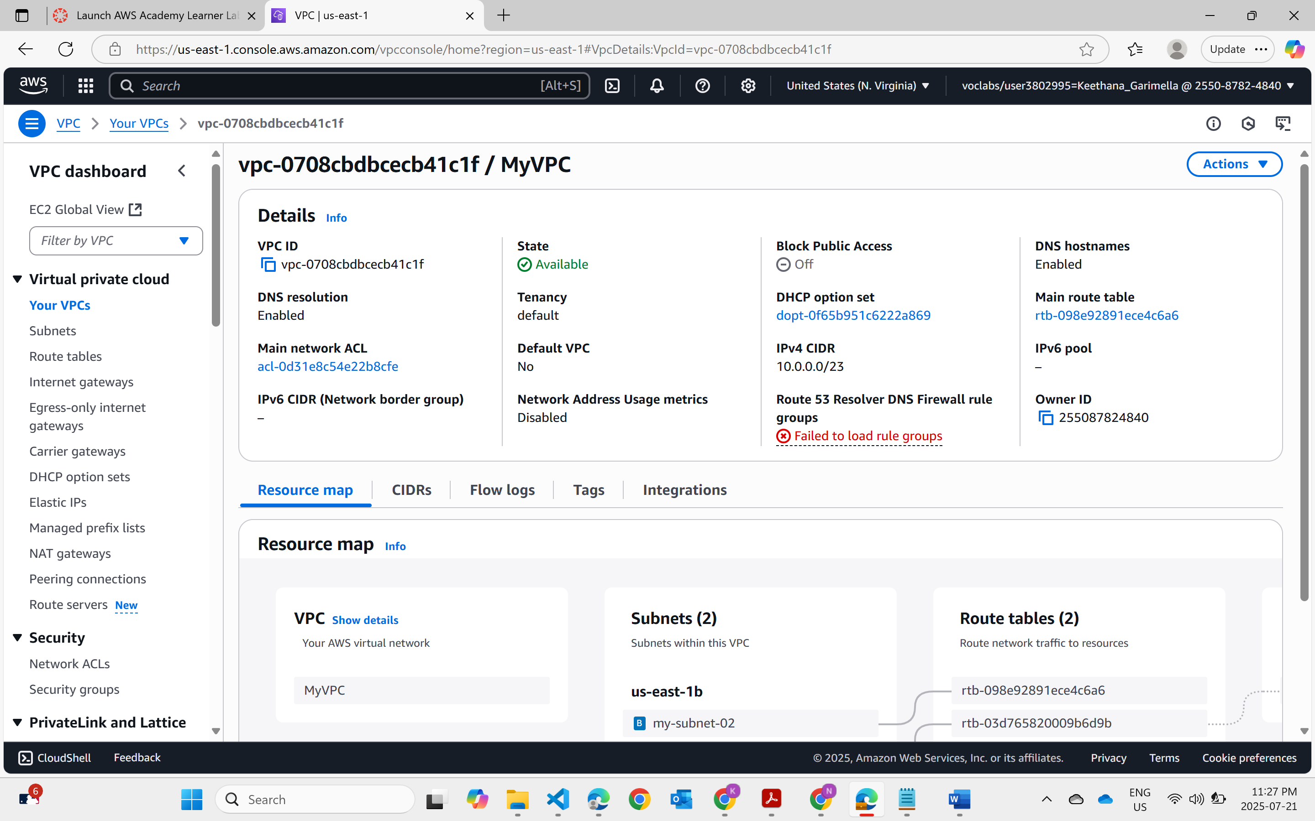  
  
VPC creation   
The VPC with CIDR block 10.0.0.0/23, two subnets, and an Internet Gateway have been created to establish a public networking.

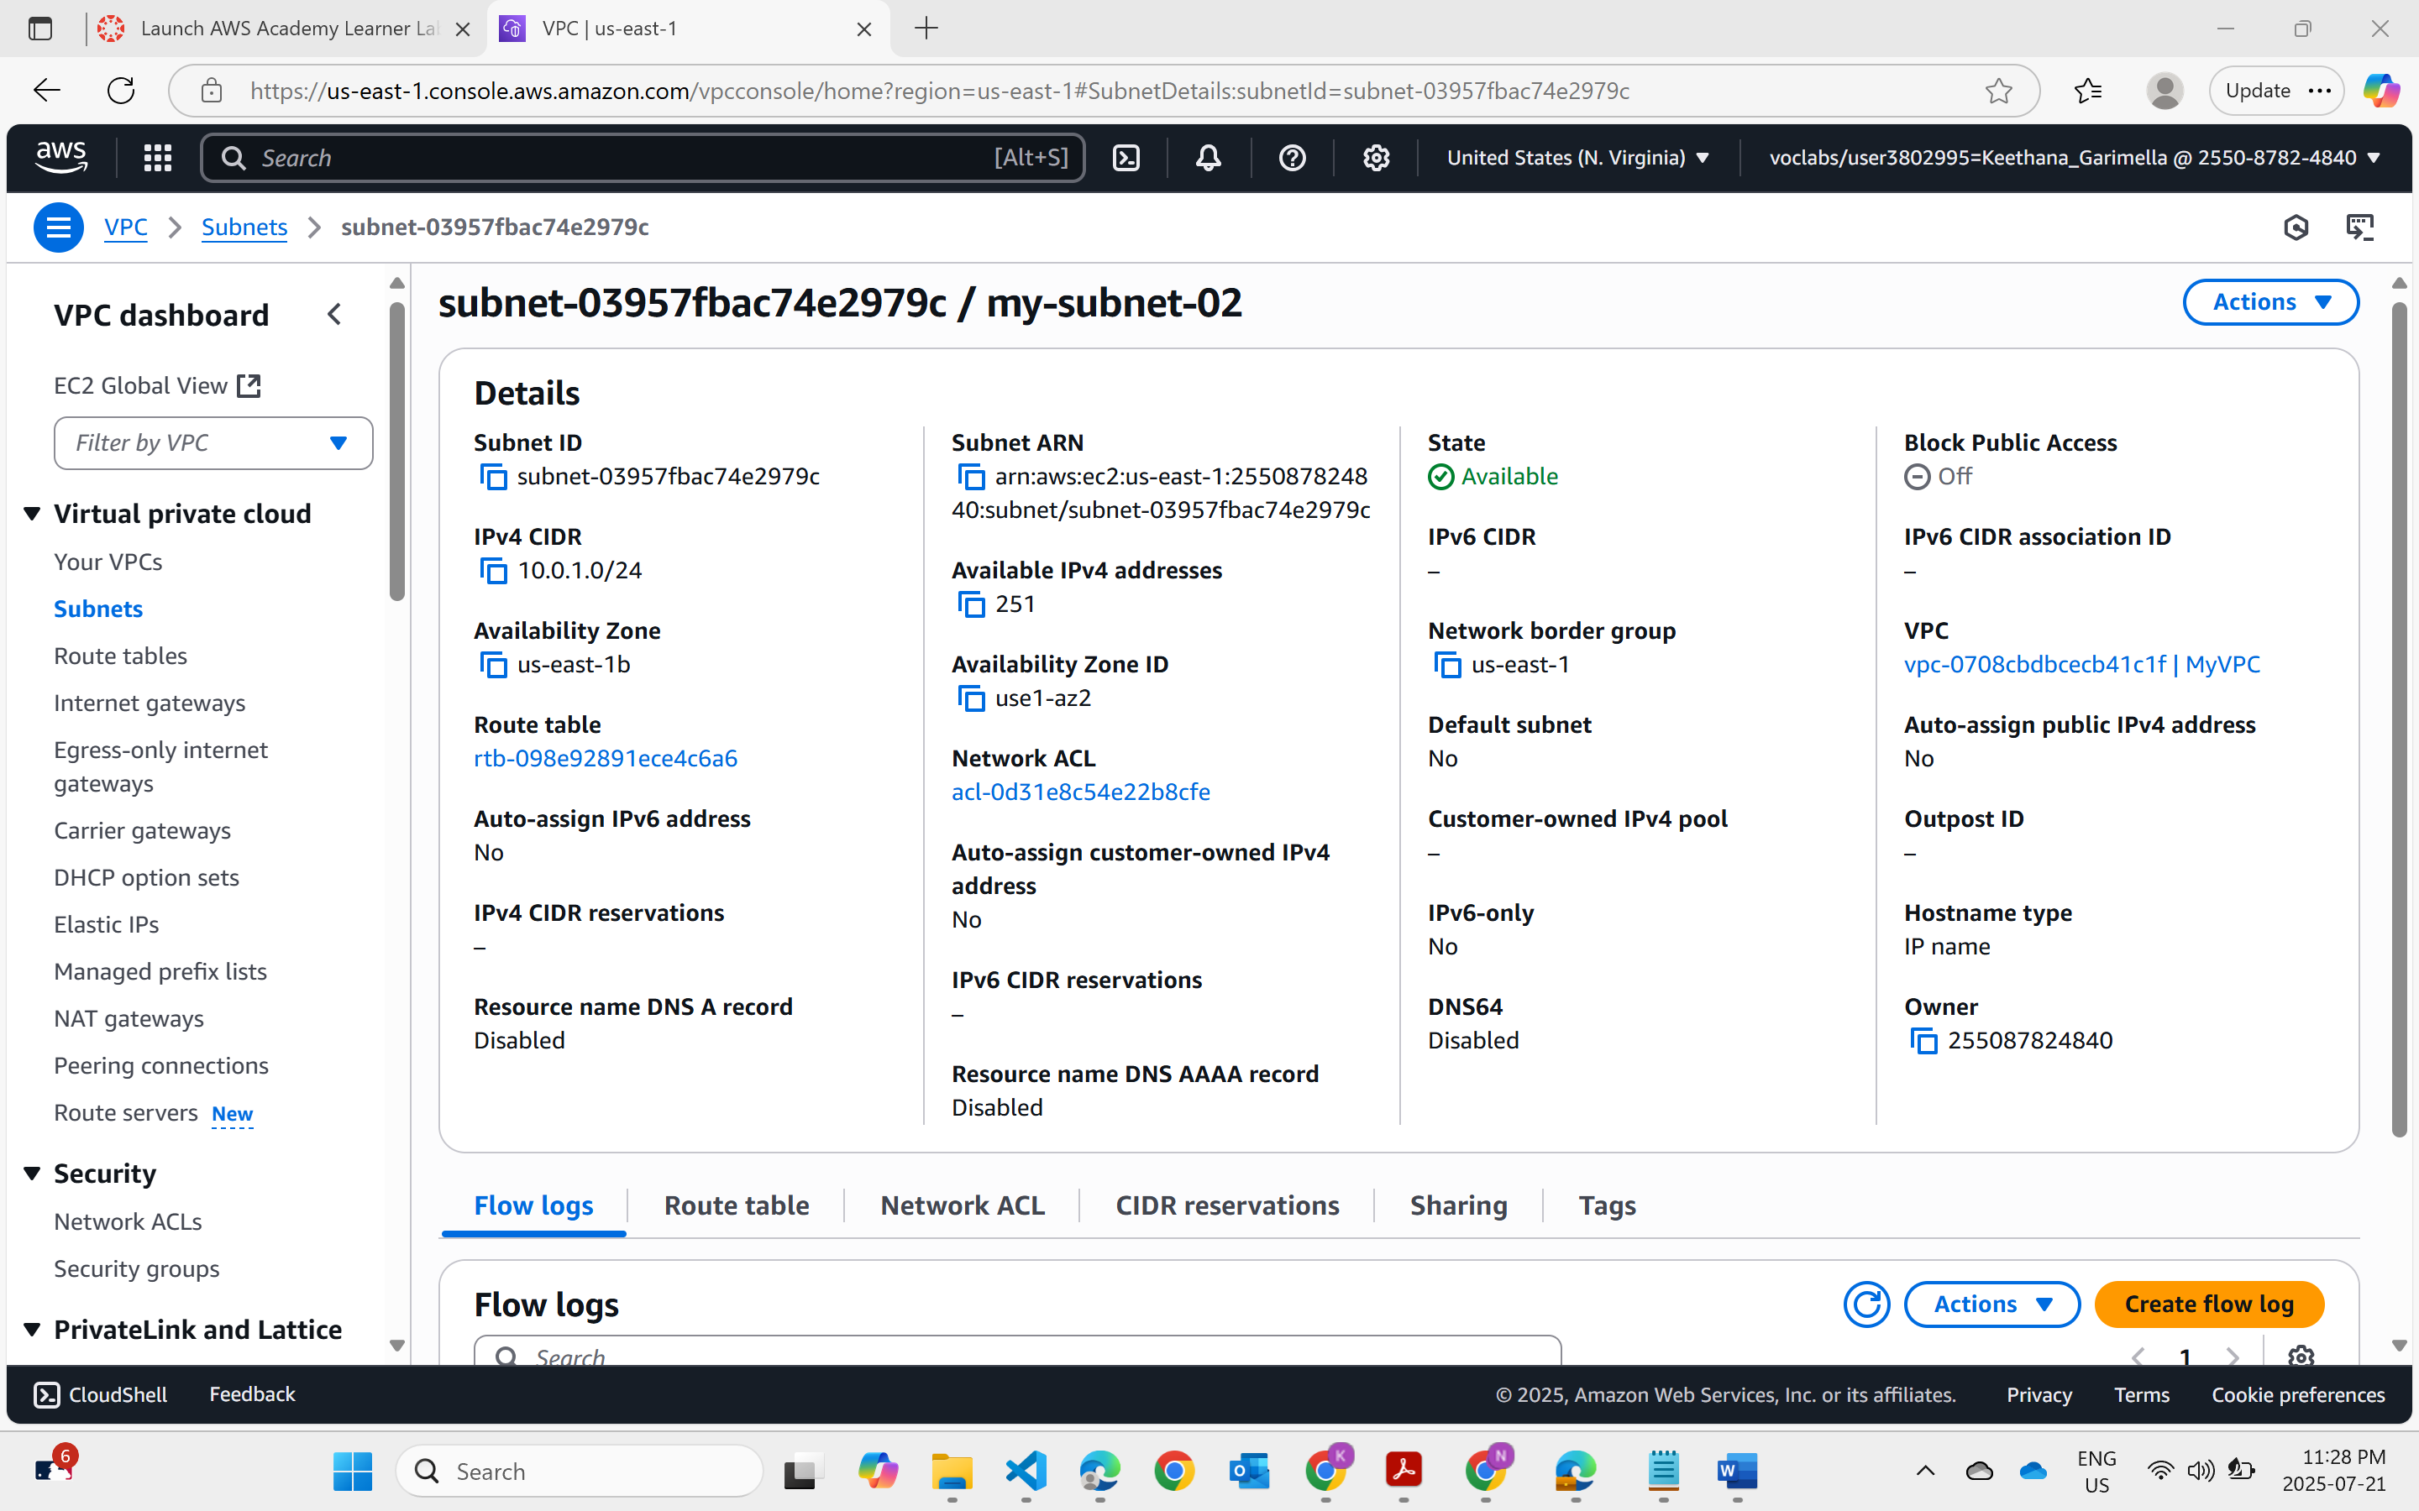  
Subnet -02  
  
  
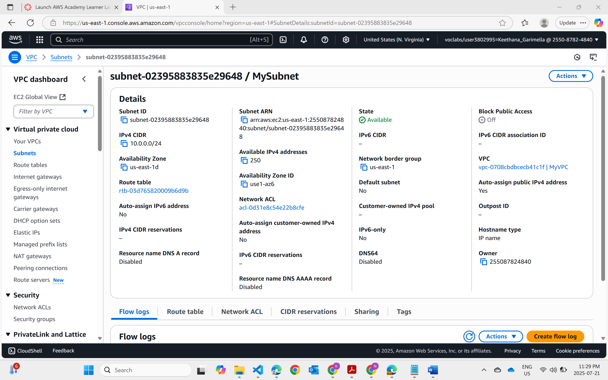  
subnet-01  
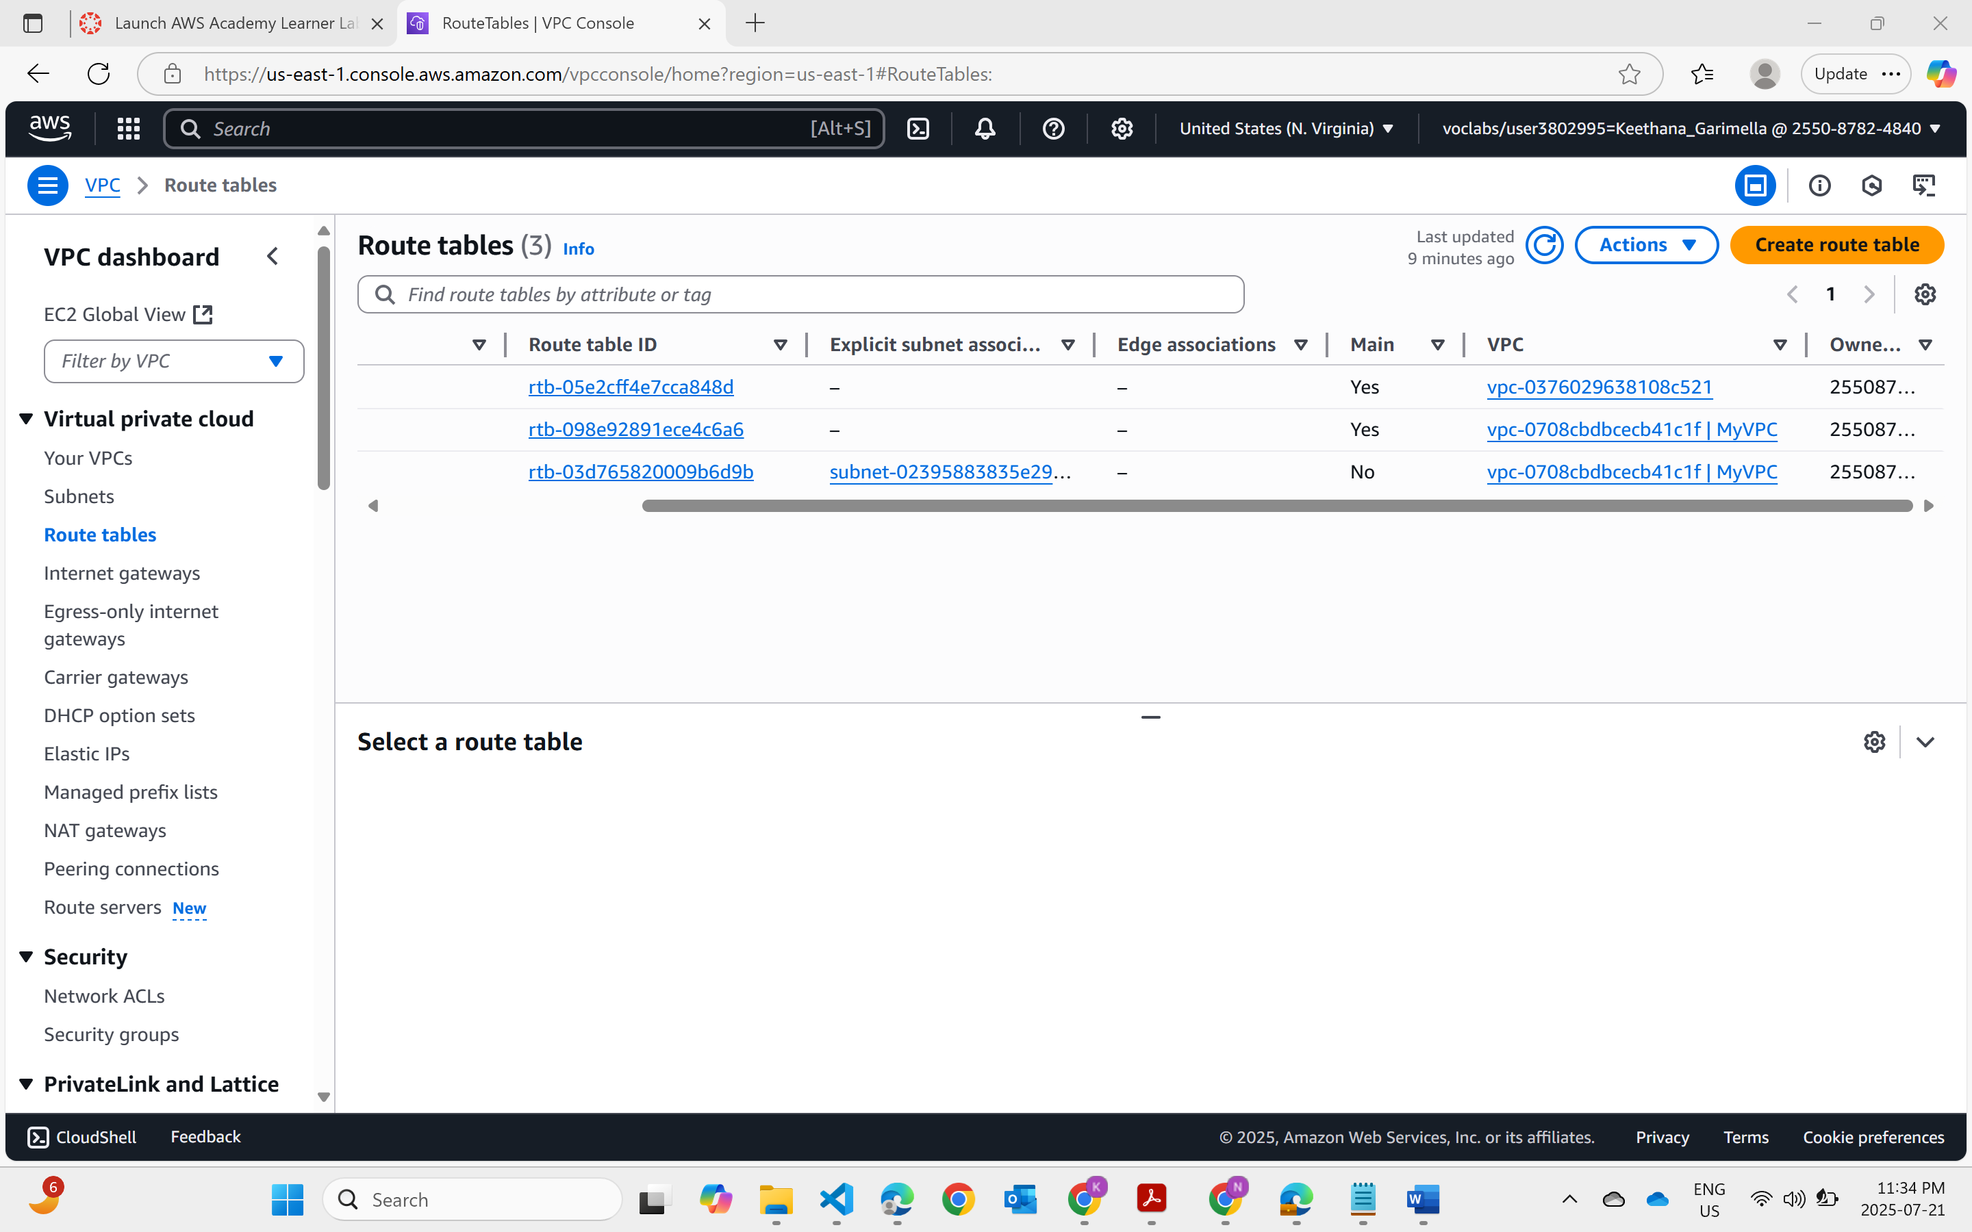  
Route tables

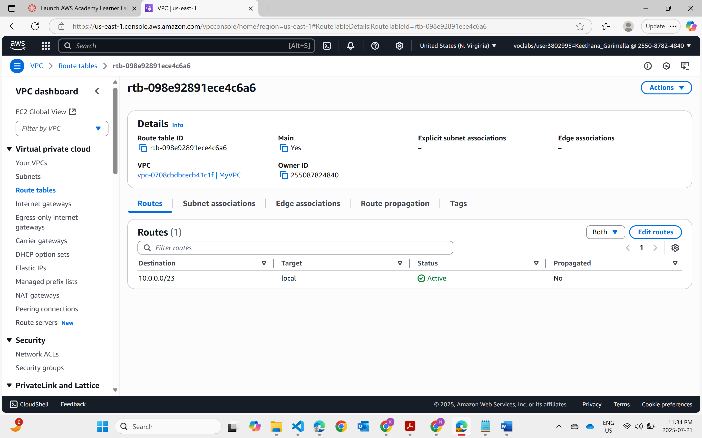  
Route tables with Id

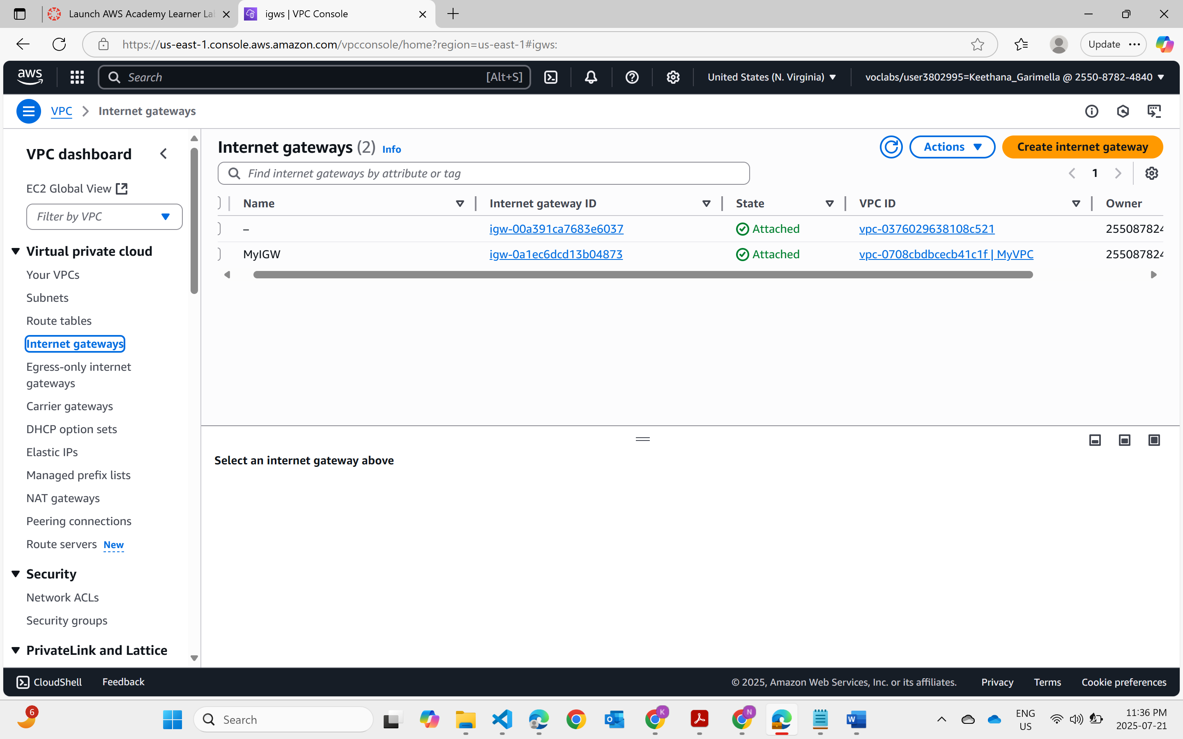  
Internet gateway  
  
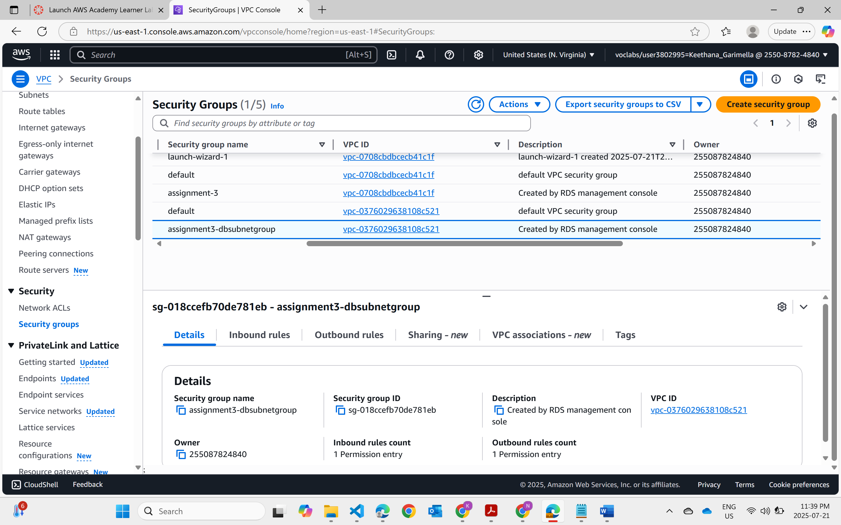  
Security groups

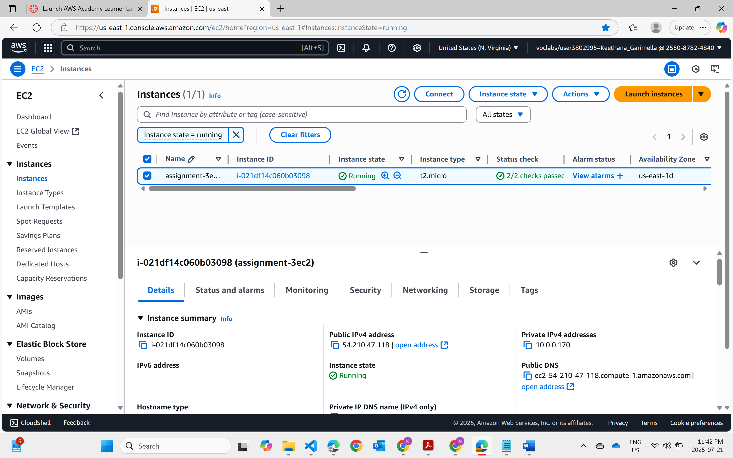  
EC2 Instance  
An EC2 instance was launched and is publicly accessible. Below is the screenshot showing the running EC2 instance and its Public IP.

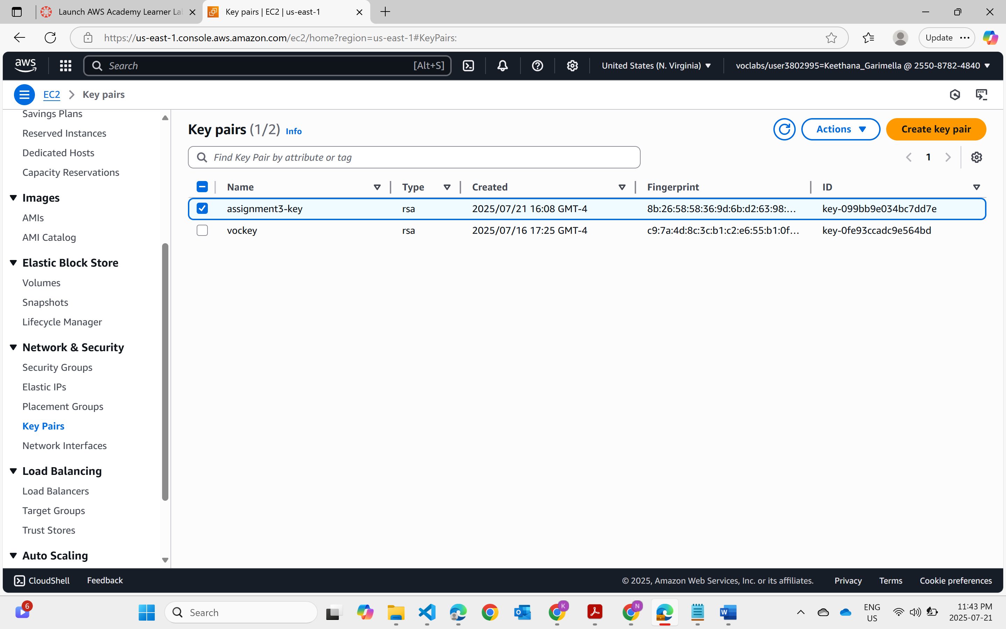  
Key pairs

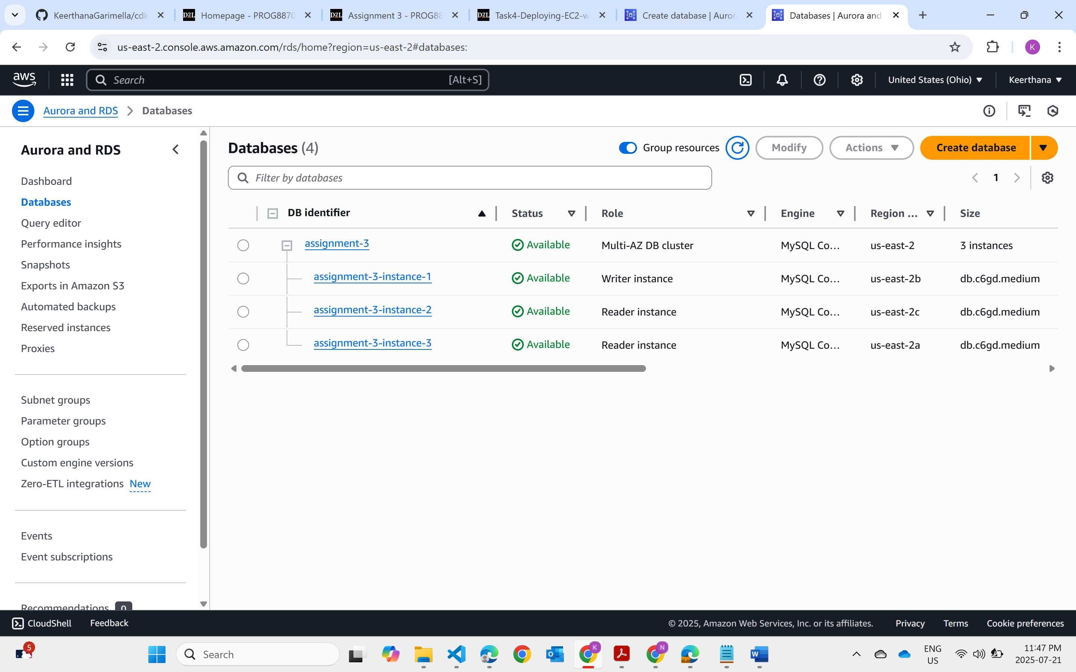  
An Amazon Aurora MySQL-compatible RDS instance cluster with writer and two reader nodes has been created successfully.  
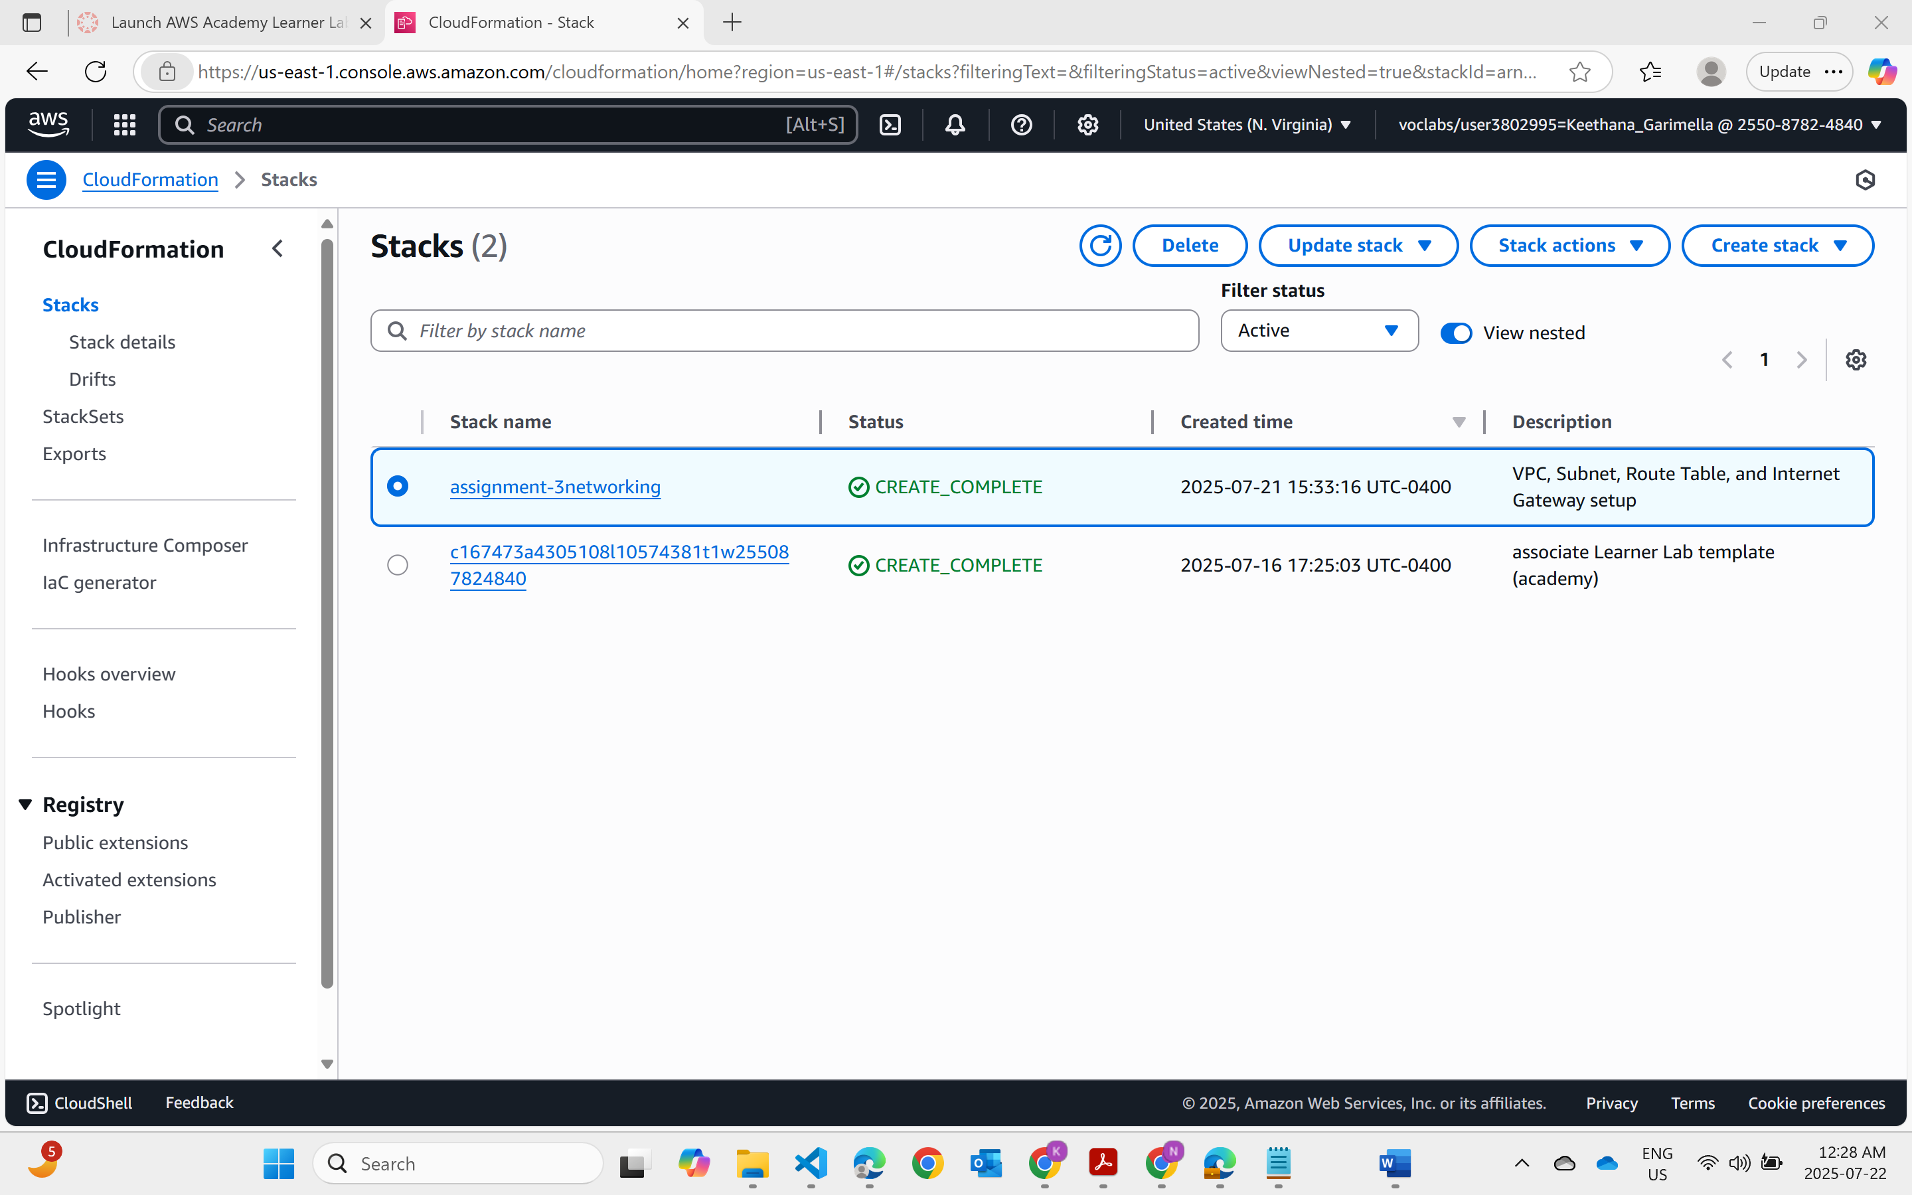  
  
network stack creation

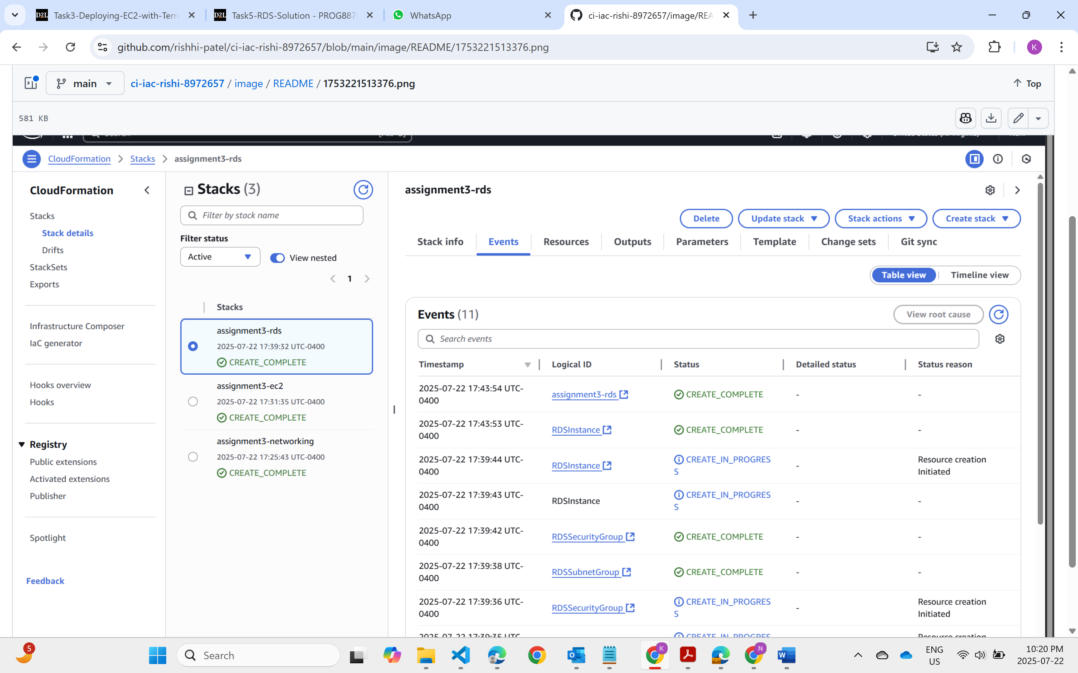  
  
stacks created

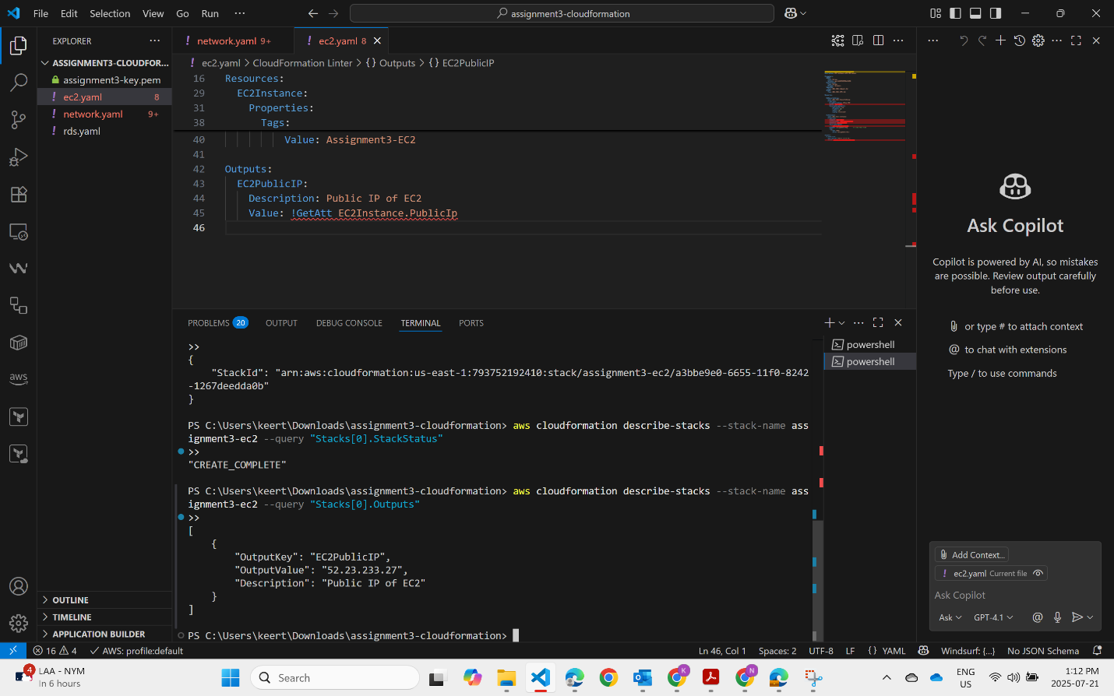  
Output  
  
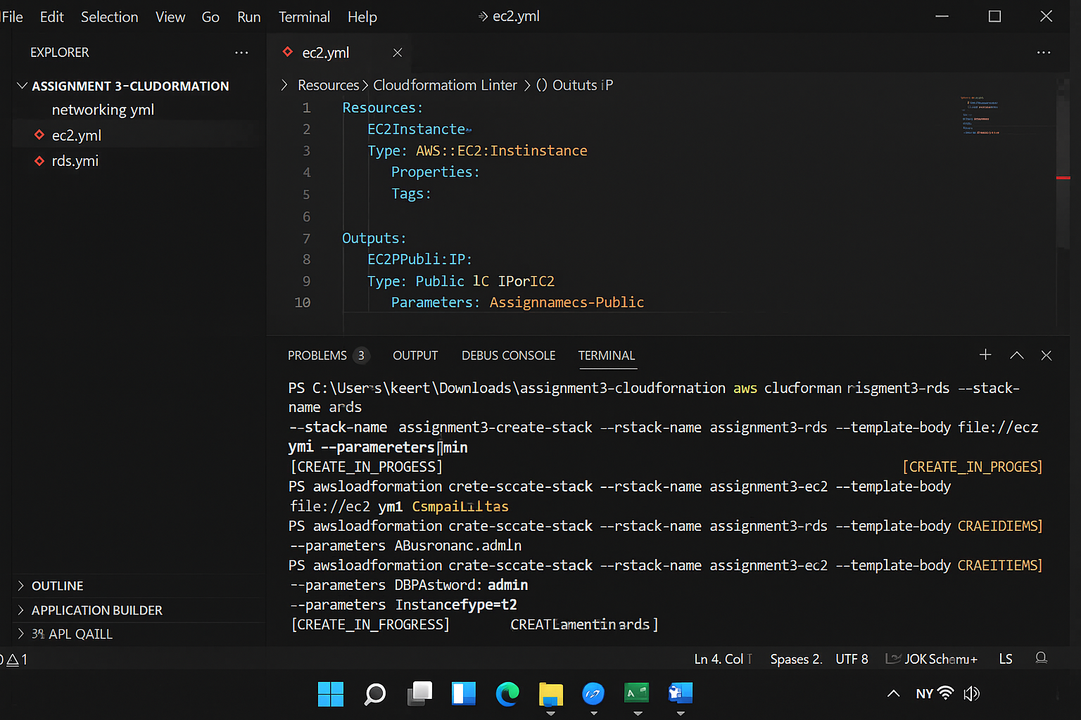

**Deploy Networking Stack**

aws cloudformation create-stack --stack-name assignment3-networking --template-body file://networking.yml --capabilities CAPABILITY_NAMED_IAM  
  
**Deploy EC2 Stack**  
aws cloudformation create-stack --stack-name assignment3-ec2 --template-body file://ec2.yml --capabilities CAPABILITY_NAMED_IAM --parameters ParameterKey=AMI,ParameterValue=ami-0cbbe2c6a1bb2ad63 ParameterKey=InstanceType,ParameterValue=t2.micro  
  
**Deploy RDS Stack**

aws cloudformation create-stack --stack-name assignment3-rds --template-body file://rds.yml --capabilities CAPABILITY_NAMED_IAM --parameters ParameterKey=DBUsername,ParameterValue=admin ParameterKey=DBPassword,ParameterValue=Password123!